A000-Asia-China-Hongshan-Niuheliang**-Dragon-C shape-Jade-**4700 to 2920 BCE

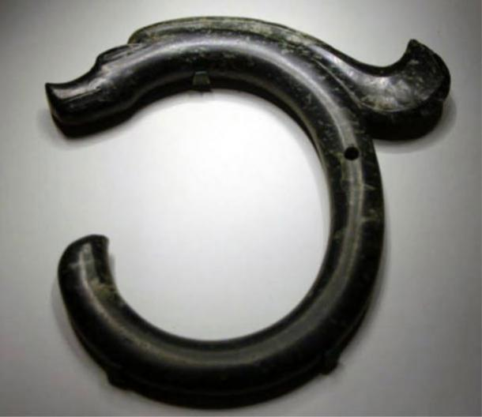

Fig. 1. Niuheliang**-Dragon-C shape-Jade-**Hongshan Neolithic culture (4700 to 2920 BCE)

**Case no.: 5**

**Accession Number:**

**Formal Label:** Niuheliang**-Dragon-C shape-Jade-**Hongshan Neolithic culture (4700 to 2920 BCE)

**Display Description:** The Hongshan Neolithic culture (4700 to 2900 BCE) is named after Hongshanhou Chifeng. Site discovered by the Japanese archaeologist Torii Ryūzō in 1908 and extensively excavated in 1935 by Kōsaku Hamada and Mizuno Seiichi. The present Dragon Head appears to have been a central votive object of an otherwise unknown ancient Hongshan religion practiced at a shrine at Niuheliang (牛河梁) in Liaoning Province, Northeast China, which was discovered in 1983. This site includes an underground temple complex with painted walls —which included an altar, a repository (aka Goddess Temple, nüshenmiao 女神庙) of clay figurines of larger than life-size goddesses (?) including a clay female head with jade inlaid eyes, and cairns which entombed jade turtles and C-shaped jade dragons like this one as a votive object (Liaoning 2008; UNESCO. 2005).

**LC Classification:** NK 5750.2 C6

**Date or Time Horizon:** Hongshan Neolithic culture (4700 to 2920 BCE)

**Geographical Area:** Niuheliang (牛河梁) in Liaoning Province

**Map:**

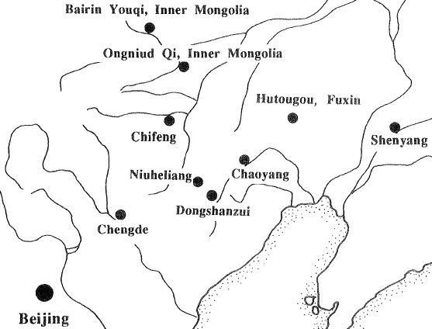

After Barnes and Guo 1996.

**GPS coordinates:** N 41°16′15″ , E 119°27′9″

**Cultural Affiliation:** Hongshan Niuheliang Religion.

**Medium:** jade.

**Dimensions:**

**Weight:**

**Condition: original.**

**Provenance:** Liaoning.

**Discussion:**

Two ceremonial sites of Dongshanzui and Niuheliang have been identified so far (Li 2003). Niuheliang consists of thirteen tomb clusters on hill promontories, a large double cruciform-shaped pit structure, and a summit with four compounds. A cadre of jade sculptors and accomplished ceramicists who provided élite burial goods suggest an organized labor body. An artificial hill at Niuheliang contained three rings of marble-like stones and several high cairns with elaborate interiors and a 22 m-long building which contained fragments of life-sized statues. One of the fragments was a face with inset green jade eyes. Elite burials of at least three ranks (Nelson 1996) suggest of a ranked society. These burials include decorative possibly iconographic jade objects such as this dragon votive object. Non-élite interments have not been found.

**References:**

Barnes, G. L.; Dashun, Guo. 1996. "The ritual landscape of 'Boar Mountain' Basin: The Niuheliang site complex of north‐eastern China," World Archaeology **28** (2): 209–219.

Guo, Dashun 1994. Hongshan and related cultures. In *Beyond the Great Wall: The Archaeology of Northeast China* (ed. S. M. Nelson). London: Routledge. Hamada,

Kosaku and Mizuno, Seiichi 1938.” Hung-shan-hou, Chihfeng: Prehistoric Sites at Hung-shan, Chihfeng in the Province of Jehol, Manchukuo,” *Archaeologia Orientalis* Series A, Vol. 6.

Liaoning Provincial Museum *et al.* 1977. “Discoveries of the earliest culture in Sanzhongyang, Xiaoheyang, Aohan Banner, Liaoning,” *Wenwu*, 1977. 12:1-22.

Liaoning. 2008. Provincial Institute of Cultural Relics and Archaeology 辽宁省文物考古研究所,

“Niuheliang Hongshan wenhua di er didian yihao chongshi guanmu de fajue” 牛河梁红山文化第二地点

一号冢石棺墓的发掘 (Excavation of the Central Tomb of a Boulder Mound at the Hongshan Culture

Site of Niuheliang, Locality 2). *Wenwu* 文物10: 12

LPARI 1986a. Brief report on the excavation of the 'Goddess Temple' and the stone graves of the Hongshan culture at Niuheliang in Liaoning Province. *Wenwu* 8: 1-17 (in Chinese).

LPARI 1986b. “Brief report on exploratory excavation of Neolithic ruins in Chahai, Fuxin,”*Liaohai Wenwu Xuegan*, 1: 154-8 (in Chinese).

Nelson, S. M. 1991. The 'Goddess Temple' and the status of women at Niuheliang, China. In The Archaeology of Gender: Proceedings of the 22nd Annual Chacmool Conference (ed. D. Walde and N. Willows). Calgary: The Archaeological Association of the University of Calgary.

Nelson, S. M. in press. Hongshan, an early complex society in northeast China. IPPA Bulletin, forthcoming. Sun, Shoudao and Guo, Dashun 1984. On the primitive civilization of the Liao river basin and the origin of dragons. Wenwu, 1984. 6:11-20 (in Chinese).

Christian E. Peterson, Xueming Lu (吕 学 明), Robert D. Drennan, Da Zhu (朱 达). 2010.

*Proceedings of the National Academy of Sciences of the United States of America*, 107: 13 (March 30), pp. 5756-5761

Sun, Shoudao and Guo, Dashun 1986a. Discovery and study of the 'goddess head sculpture' of the Hongshan culture at Niuheliang, *Wenwu*, 1986. 8:18-24 (in Chinese).

Sun, Shoudao and Guo, Dashun 1986b. Hongshan: a lost culture. China Pictorial, 1986. 8: 2-7.

UNESCO. 2005. Sites of Hongshan Culture: The Niuheliang Archaeological Site, the Hongshanhou Archaeological Site, and Weijiawopu Archaeological Site. unesco.org

Zhou, Nanquan. 2005. *Hongshan, ca. 4700-2920 BCE: Chinese jades of the Hongshan culture*. New York: Throckmorton Fine Art.